

**Learning Style Assessment**

1. Go to [www.wois.org](http://www.wois.org) and log on with your **Site Key**.



1. Log in with your **User ID** and **Password**



1. Click **Log in**
2. Click on “**Assessments”** in the navigation panel on the left side of the screen.
3. Click on **“Other Assessments.”**



1. Click **Learning Style** to begin the assessment.
2. This will take you to the site **Three Different Learning Styles- *What’s YOUR Learning Style?***
3. To start the test, click the link to **Take the Inventory**.
4. When you finish answering all the questions, click **“Submit Query.”**
5. This will provide the results of your test and give you your Learning Style. **\*Do not close the results window!**
6. Go back to WOIS and click **Portfolio** then **Assessments/Tests.**



1. Click **“Add New Assessment”**

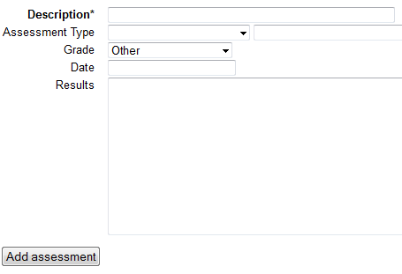

1. Fill in the information based on your **Learning Style** assessment and click **“Add Assessment.”**
2. Your results will now show under the **Assessments**.